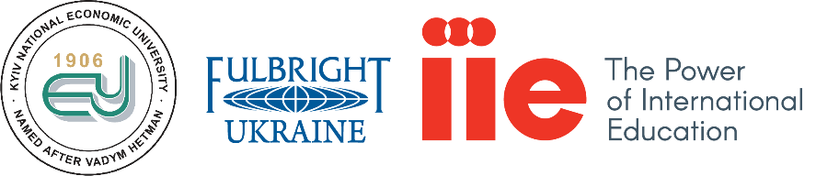
The Kyiv Vadym Hetman National Economic University and the Fulbright Program in Ukraine
Digital Learning with Emerging Technologies
Digital technologies are more and more used to promote understanding of subject matter in the university classrooms. Cognitive engagement, motivation, meaningful learning and self-reflection (i.e. meta-cognition) are some of the other benefits of using technologies in the classroom. In this presentation, participants will explore various methods and tools to teach with new digital technologies. Some of the topics covered will be Web 2.0 technologies, Augmented Reality, Internet of Things (IoT), Social Bookmarking, Social Concept Mapping, Infographics and Digital Storytelling.
At the end of the workshop, all participants will be able to:
- Discuss value of technology use and integration in learning environments,
- Explore strategies for teaching with new pedagogies and technologies,
- Use various emerging technologies for effective learning, teaching and assessment.

Date: December 14, 2017 Wednesday
Time: 16;00
Location: KNEU, main Building, Room 412, Prospect Peremohy, 54/1

No previous background with technology required.
(Note: The instructor will use a very practical and hands-on approach so for best experience, please Bring Your Own Device (BYOD).
Instructor: Dr. Betul Czerkawski
Dr. Betul Czerkawski serves as an Associate Professor in Educational Technology and SLAT (Second Language Acquisition and Teaching) programs in the University of Arizona. Dr. Czerkawski has taught and researched at the higher education level in a variety of roles, as Professor, Program Director, Program Coordinator, Fulbright Grant Manager, Fulbright Specialist to Kosovo, Post-Doctoral Researcher, Distance Education Mentor, Course Designer, Doctoral Advisor, and Journal Editor for over two decades.

Her research interests include online instructional design, emerging technologies, designing e-learning environments, and computational thinking. She has presented and published over 80 papers on these subjects. She is also the editor of a peer-reviewed journal, Issues and Trends in Educational Technology (ITET) at https://journals.uair.arizona.edu/index.php/itet/index.

Currently, Dr. Czerkawski is a Fulbright Scholar (2017-2018) at the National Technical University of Ukraine “Ihor Sikorsky Kyiv Polytechnic Institute”

Moderator: Svitlana Usherenko, Associate Professor in the Department of Corporate Finance and Controlling at the Kyiv Vadym Hetman National Economic University.

