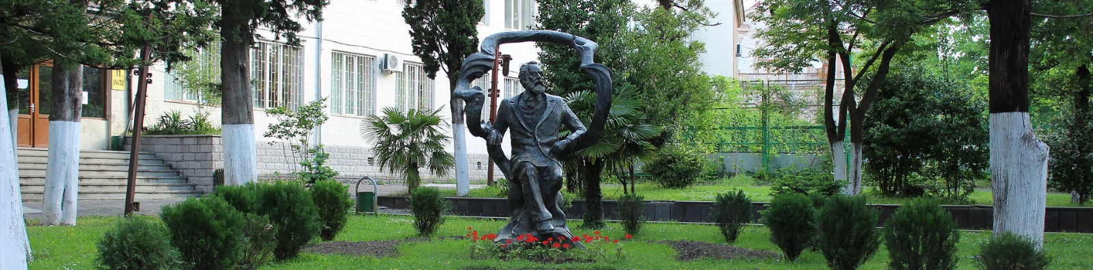

AKAKI TSERETELI STATE UNIVERSITY IN KUTAISI, GEORGIA

Dear Colleagues,
The Faculty of Humanities at Akaki Tsereteli State University in Kutaisi, Georgia will host a two-day international multidisciplinary conference "The Humanities in the Age of Globalization". The conference will be held at Akaki Tsereteli State University from November 1-2, 2019. The wide range of subjects that will be covered in the conference include but are not limited to:
- Kartvelian/Georgian Studies
- Linguistics
- Literature Studies
- History and Social Sciences
- Archaeology and Cultural Heritage
- Ethnic and Cultural History
- Art and Culture
- Globalization and Intercultural Dialogue
- Middle Eastern Languages and Civilizations
- Global and Area Studies
- Philosophy and Religious Studies
- Archive Studies and Museum Work
- Psychology
- Translation Studies
- Environmental/Ecological Humanities
- Information Technologies, Communication Studies, and Humanities
- Innovative Methods and Technologies of Teaching and Research
- Antropocene: Environmentalism and Post-Humanism
- Digital Humanities
Please visit the conference webpage
https://atsu.edu.ge/Conferences/humanitiesconf/index.php?page=content&lng=En to submit a proposal through the online application system.
Individual as well as fully-formed panel proposals are welcomed on any subject in the Humanities. Proposals for individual papers should be 300 words maximum, including the paper title, the speaker's name and academic affiliation (if applicable).
Please provide 4-8 keywords, separated by comma. To propose a panel, the panel chair should submit a 300-word abstract on the panel as a whole that includes the names, academic affiliations, and email addresses of all participants; the title of the panel as well as the titles of each individual contribution; and the name and affiliation of the panel chair.
Panel proposals should also include a 250-word abstract for each constituent paper. Please note that panels should have a maximum of four speakers.
All proposals should be submitted no later than July 20, 2019.

Please note the following:
Conference working languages will be Georgian, English, German, French and Russian;
Time Limit for Keynote Speakers: 30 minutes;
Time Limit for Panelists: 15 minutes;
Time Limit for Discussions: 5-7 minutes;
Equipment for the projection of PowerPoint presentations will be available upon request.

Registration Fee: 30 EURO (including taxes). Registration fee includes:
- conference program,
- certificate of participation,
- tea/coffee, refreshments during the coffee breaks, two lunches,
- sightseeing tours in Imereti region.
The Fee should be paid by wire transfer to the conference bank account.
Except plenary sessions, keynote presentations and panels, the outdoor activities will be offered. The participants will visit historical sites and places of interest surrounding the ancient city of Kutaisi.
Papers will be published as a journal by Akaki Tsereteli State University Press.

Application Submission:
Application should be filled in English and submitted online by July 20, 2019; applicants are authorized to submit no more than one proposal; abstract should contain 300 words maximum; paper should have no more than 3 authors.

To fill the Application, please follow the link https://atsu.edu.ge/Conferences/humanitiesconf/index.php?page=content&lng=En
Acceptance/rejection notifications will be sent by august 1, 2019.

The registration fee (30 EURO) must be paid no later than September 25, 2019 by wire transfer to the following bank account:

Beneficiary’s bank: NATIONAL BANK OF GEORGIA, TBILISI
SWIFT CODE: BNLNGE22
Beneficiary: LEPL AKAKI TSERETELI STATE UNIVERSITY
IBAN: GE65NB0331100001150207
Payment receipt - "The Humanities in the Age of Globalization – 2019" and author's name.
Intermediary: JP MORGAN CHASE BANK NEW YORK, USA
SWIFT CODE: CHASUS 33
ACC: 409346371
Registration to the conference is mandatory. A copy of the payment order/receipt should be sent to the Organizing Committee by e-mail: humanitiesconf@atsu.edu.ge

Venue:
The conference will be held at Akaki Tsereteli State University, 59 Tamar Mepe st., Kutaisi, Georgia.

Useful Information:
Registered participants will receive a personal badge along with the conference folder. They will be offered lunches and coffee breaks and will be able to access the Internet through the university Wi-Fi network.

HOW TO GET TO KUTAISI
You can take a cheap direct Wizz Air flight to Kutaisi International Airport. For more information, please visit:
http://www.kutaisi.aero
https://wizzair.com/en-gb#/
You can also fly to Tbilisi and Batumi International Airports:
http://www.batumiairport.com/flightInfo.aspx
http://www.tbilisiairport.com/en-EN/Pages/Main.aspx
You can also get to Kutaisi via Tbilisi or Batumi by train: https://beta.tkt.ge/railway

A LIST OF HOTELS IN THE CITY:
http://www.booking.com/city/ge/kutaisi.en.html
Hotels located in the central district near the Akaki Tsereteli State University are closer to the conference venue: Hotels In The Central Disctrict. You may also look at various accommodation offers on Airbnb.

Yours sincerely,
Conference Organizing Committee

