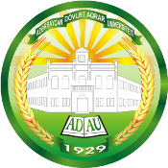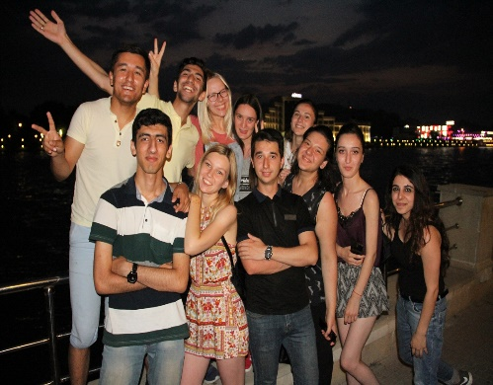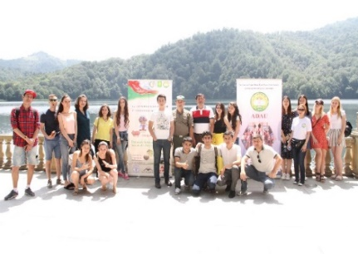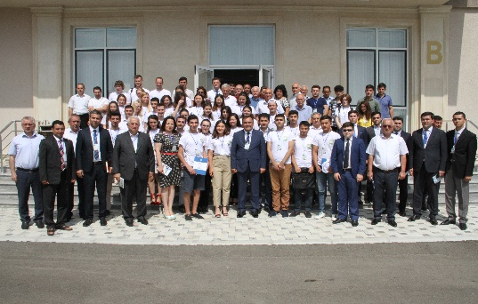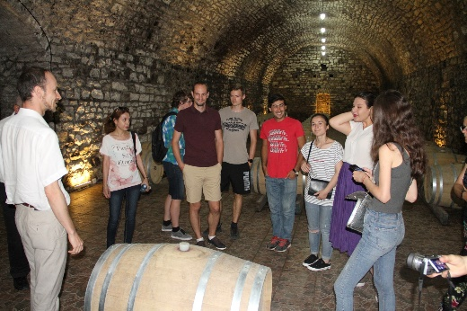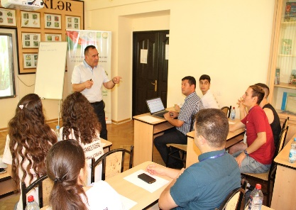

**II ADAU INTERNATIONAL SUMMER SCHOOL  
“Innovative development of the agrarian sector:**

**World experience and prospects”, *08-18 July 2019***

Azerbaijan State Agricultural University (ADAU) is organizing an International Summer School on the theme “Innovative development of the agricultural sector: world experience and prospects". The purpose of the school is to discuss the current state and prospects of the innovative development of the agricultural sector by gathering students of bachelor degree from local and foreign universities.  
**Date: *July 08-18, 2019***  
**Venue: *Ganja, Azerbaijan***  
**Deadline: *May 31st, 2019***  
- **Who can participate?** Undergraduate students.

**Program language:** English

**Registration fee:** No registration fee is required.

**Accommodation and meals**: Accommodation and meals at ADAU Student House (CAMPUS).

**Travel expenses**: Participants cover their own travel expenses.

**Lecturers and teachers**: Representatives of the FAO Partnership and Coordination Office in Azerbaijan, officials and experts of the Ministry of Agriculture, the Ministry of Ecology and Natural Resources, Azerbaijan State Agricultural University and others.

**How to apply**: CV (including certificates), a motivation letter, Student ID, and a copy of the passport should be sent to: [*ird@adau.edu.az*](mailto:ird@adau.edu.az) [*adausummerschool@gmail.com*](mailto:adausummerschool@gmail.com)

Please refer to the link below for more information about previous summer school: [http://adau.edu.az/1st-international-summer-school](https://l.facebook.com/l.php?u=http%3A%2F%2Fadau.edu.az%2F1st-international-summer-school%3Ffbclid%3DIwAR2zuvhf_06-XHK9dLX94dH5_knDWsLMoHbKKVhYugfCZ2eNupmxxA9LJUw&h=AT0m6v9JOlBMZPaUztiIEjgc2KXCeGKuY7glHy2MDUh3LktBQBLtf8uoTH6KV9PdBNuqqculvuvVOVbE5XxZblbXHUCAJTuI_KfHLD0RNoXVpYph3SaaWvx07g6nuUtuGL1XshfhJKmutG_FhDVdALa2RTWm0Rlr2sNivOzm5HYLsbE4njjVlmw7vdSbKxg_aB6ut4UkGbHK0ura7LMjWx-BdRE5w9GvIC27jcNJ-khQmNcm28OLjExM9wAT_2IgxZA4l2fERl5M8vBubFfapq5wbpiMygyRx5CKGPn26g_ptFU_PLNqvAkWp8guRiq3IgqjDdvJHI0ssr9IH_KAO9U2GlRO38xxFur48GIl9rKLZ6VIl3n8D2_R7N6go7M_05FikcA08IOb3DvZ85Orkqq0s7PbQRTG_7DXPbH2ooM-2wTOaUpprv8-93W-pSfgRVWsB66biWvn9lX-XQlcnyIIEas-1RRPJ-owXburfzrhYhXdKl3wPKvntBCF9hXswHORESLIsvh3BCVpBRwMsKKM_TFe91h2kWRG1X0U8ablA4q32OeO5x5WdFQwdcLU5nYSXQiy7wxlFzH2VxpLSxOEHgELI1r5esQFOLkFOuBey2966DcgczcitlFdcA)

For questions and more information: [adausummerschool@gmail.com](mailto:adausummerschool@gmail.com)

